4.1 Use Case Diagram
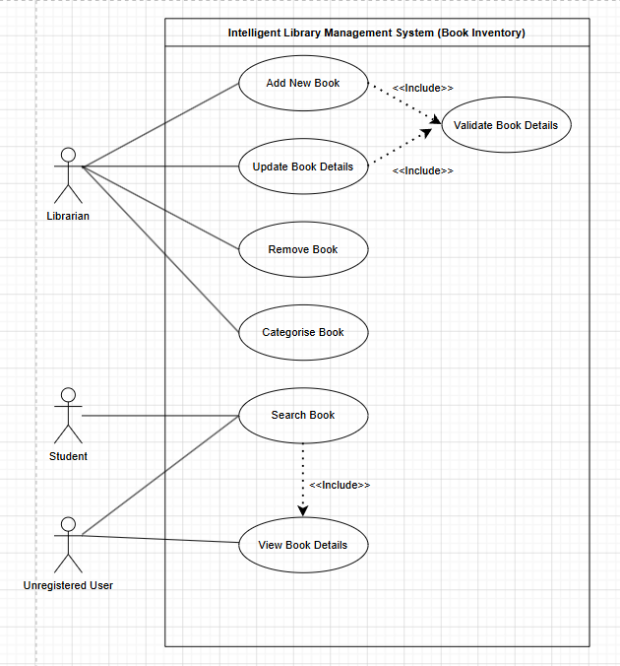

4.2 Use Case Descriptions
1.Add Book
Use Case Name | Add Book
Actors | Librarian
Brief Description | Allows the librarian to add a new book into the library inventory system.
Pre-condition | The librarian must be logged into the system and the database must be online.
Post-condition | A new book record is successfully stored in the database and becomes available in the inventory list.
Basic Flow | 1. The Librarian selects the “Add Book” module.  2. The system displays the book registration form.  3. The Librarian enters the book information such as title, author, ISBN, category, and quantity.  4. The Librarian clicks the “Save” button.  5. The system validates the entered information.  6. The system saves the book record into the database.  7. The system displays a success message.
Alternate Flow | 3a. Auto Category Suggestion: If the entered ISBN matches an existing category pattern, the system automatically suggests a suitable category for the book.
Exception Flow | 5a. Duplicate ISBN: If the ISBN already exists in the system, the system displays an error message and prevents duplicate registration.
Constraints | Only librarians are allowed to add new books into the system.

2. Update Book
Use Case Name | Update Book
Actors | Librarian
Brief Description | Allows the librarian to update existing book information in the inventory system.
Pre-condition | The selected book record must already exist in the database.
Post-condition | The selected book information is updated successfully in the system.
Basic Flow | 1. The Librarian searches for a book.  2. The system displays the selected book information.  3. The Librarian edits the required information.  4. The Librarian clicks the “Update” button.  5. The system validates the updated information.  6. The system updates the book record.7. The system displays a success message.
Alternate Flow | 3a. Quantity Update Only: The librarian updates only the quantity of available books without changing other information.
Exception Flow | 5a. Invalid Data: If mandatory fields are empty, the system displays an error notification.
Constraints | Only authorised librarians can update book information.

3.Remove Book
Use Case Name | Remove Book
Actors | Librarian
Brief Description | Allows the librarian to remove a book from the inventory system.
Pre-condition | The selected book must exist in the system and not currently be borrowed by any student.
Post-condition | The selected book record is removed from the inventory database.
Basic Flow | 1. The Librarian selects a book from the inventory list.  2. The Librarian clicks the “Remove” button.  3. The system requests confirmation.  4. The Librarian confirms the removal.  5. The system deletes the book record.  6. The system displays a success message.
Alternate Flow | 3a. Cancel Removal: If the librarian cancels the action, the system returns to the inventory page without deleting the book.
Exception Flow | 4a. Borrowed Book: If the book is currently borrowed, the system blocks the removal process and displays a warning message.
Constraints | Books currently involved in borrowing transactions cannot be removed.

4. Search Book
Use Case Name | Search Book
Actors | Student, Unregistered User
Brief Description | Allows users to search for books using keywords such as title, author, category, or ISBN.
Pre-condition | The system database must be online and accessible.
Post-condition | A list of matching books is displayed to the user.
Basic Flow | 1. The user opens the search page.  2. The user enters a keyword in the search box.  3. The user clicks the “Search” button.  4. The system searches the database.  5. The system displays matching books and their availability status.
Alternate Flow | 2a. Filter Search: The user filters the search using category or author name.
Exception Flow | 4a. No Results Found: If no matching books exist, the system displays a “Book Not Found” message.
Constraints | Internet/system connection is required to access the search function.

5. View Book Details
Use Case Name | View Book Details
Actors | Student, Unregistered User
Brief Description | Allows users to view detailed information about a selected book.
Pre-condition | The selected book must exist in the system database.
Post-condition | Detailed book information is displayed successfully.
Basic Flow | 1. The user searches for a book.  2. The system displays the search result list.  3. The user selects a specific book.  4. The system displays detailed information including title, author, category, ISBN, and availability status.
Alternate Flow | 3a. Related Books Suggestion: The system recommends similar books from the same category.
Exception Flow | 4a. Missing Record: If the selected book data is unavailable, the system displays an error message.
Constraints | Users can only view available information and cannot modify book records.

4.3 Sequence Diagrams
1. Add Book
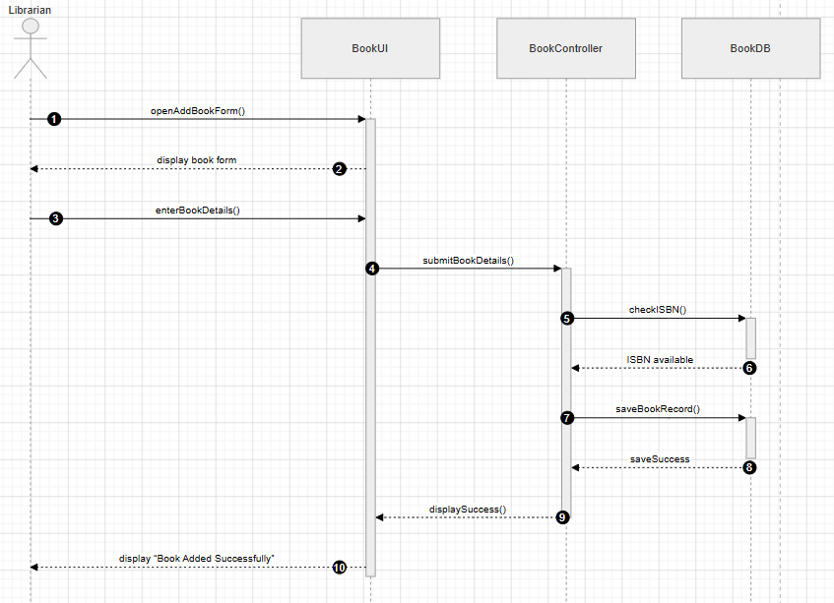

2. Update Book
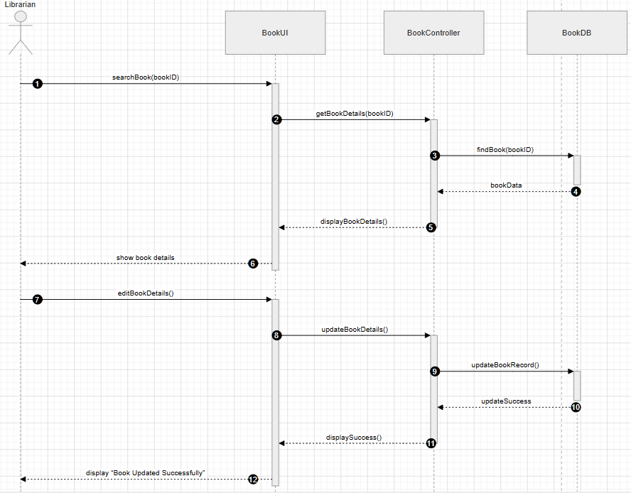

3.Remove Book
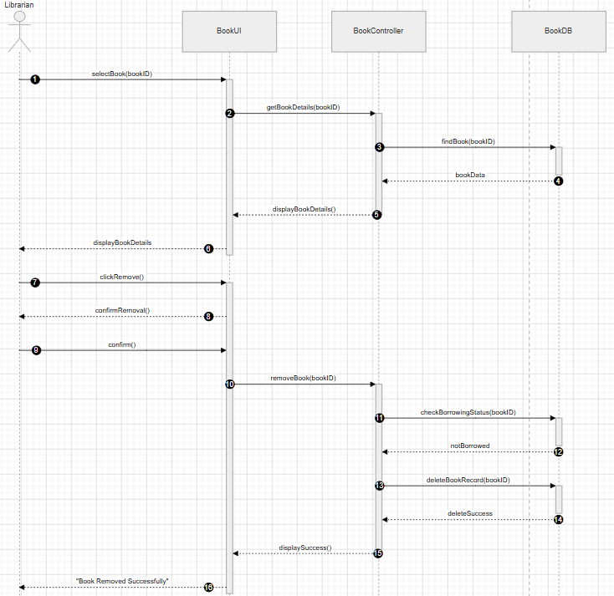

4. Search Book
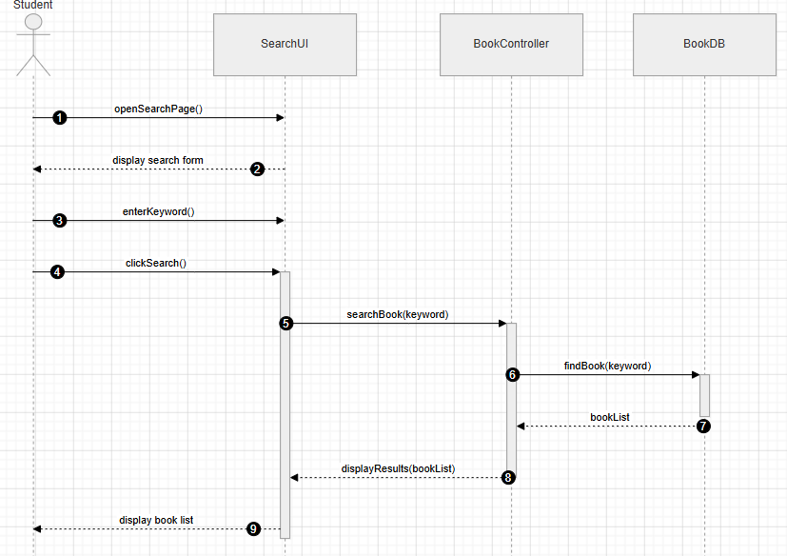
5. View Book Details
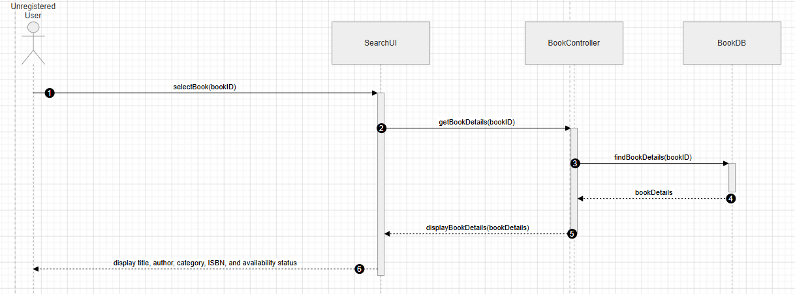

4.4 Class Diagram
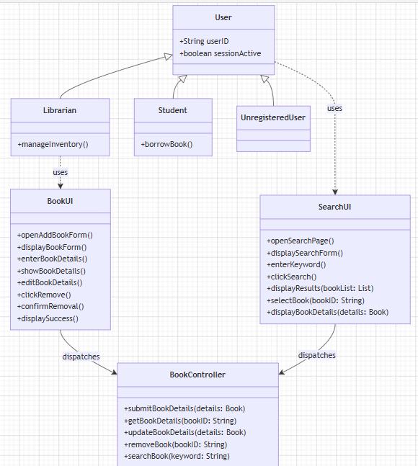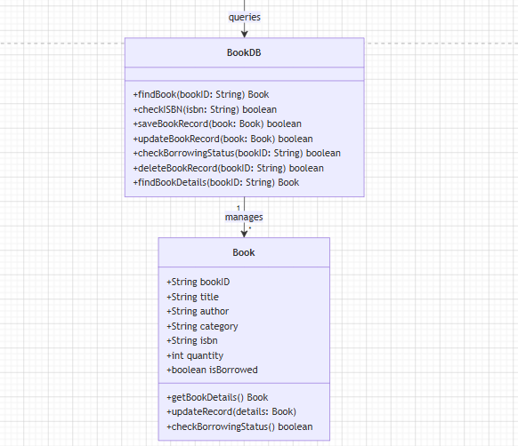
4.5 User Interface (UI) Design
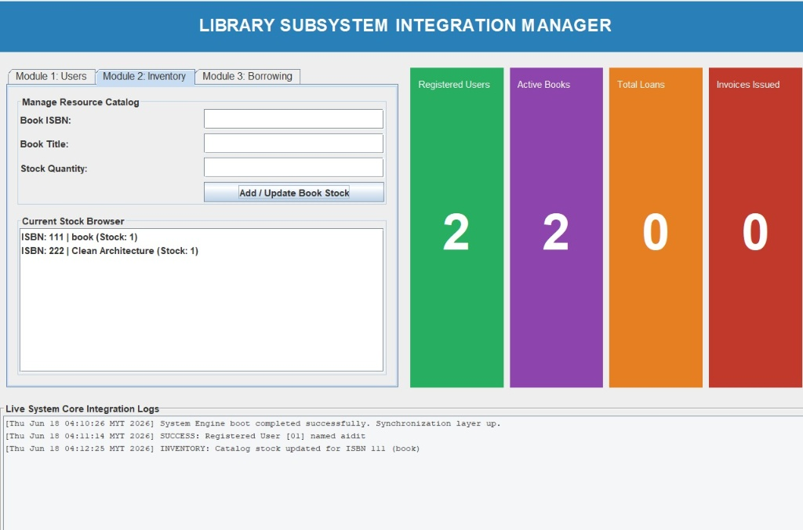
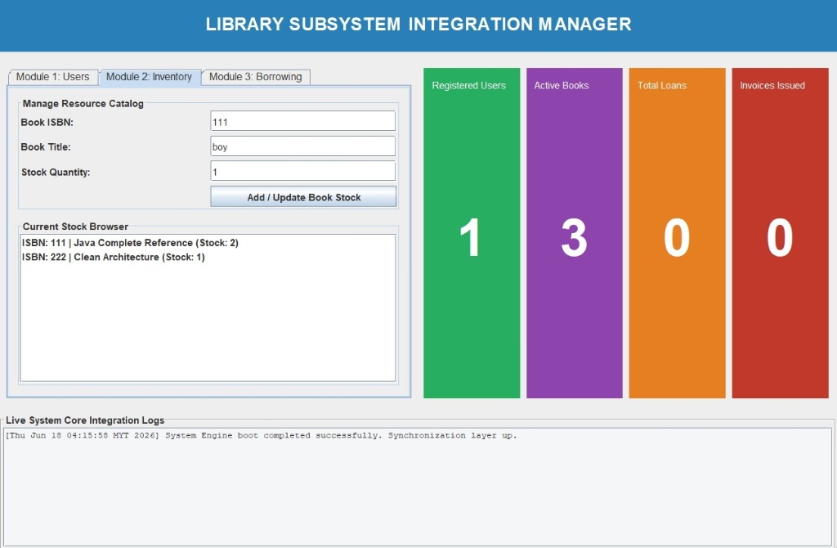
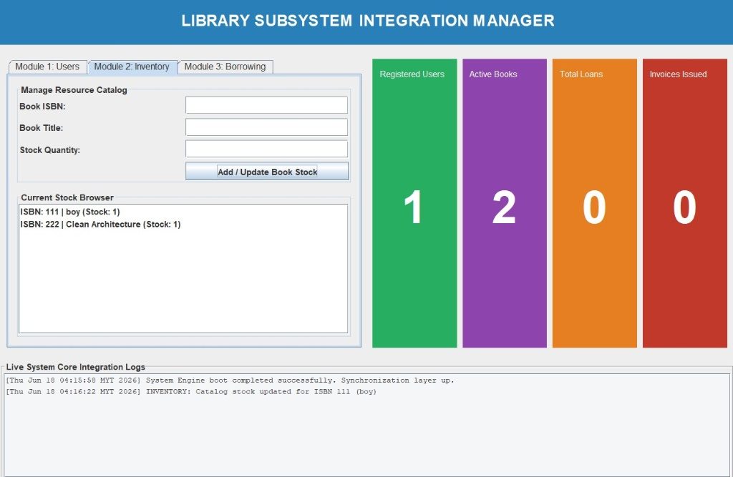
4.6 Program Implementation (Java)
The Intelligent Library Management System (Book Inventory) application is structurally constructed using the Java programming language. It relies extensively on Java Swing API frameworks for Graphical User Interfaces (GUI) and utilizes standard Object-Oriented Programming (OOP) architectures to ensure structural synchronization, high reliability, and data safety.
1. Encapsulation
Data hiding and protection constraints are actively enforced across all transactional data models. Field variables representing entity identities, catalog specifications, and quantities within classes like Student, InventoryBook, ApexUser, and ApexBook are localized within objects, preventing raw structural interference from foreign sub-components. Access modifications are regulated, and dashboard counters or central memory storage containers are bound using the private and final keywords.
Code Evidence:
Java
// From ApexLibraryDashboard.java
public class ApexLibraryDashboard extends JFrame {
// Core structural data storage maps are strictly encapsulated
private final Map<String, Student> studentsMap = new HashMap<>();
private final Map<String, InventoryBook> booksMap = new HashMap<>();
private final List<String> loanRecords = new ArrayList<>();

// GUI Visual components protected from outside class scope modification
private JLabel lblStatUsers;
private JLabel lblStatBooks;
private JLabel lblStatLoans;
private JLabel lblStatInvoices;
private JTextArea txtLogs;
}
2. Inheritance
The design pattern leverages hierarchical structures to manage multi-role system clearance requirements effortlessly. Rather than compiling isolated configurations for separate entities, modular user parameters like authentication credentials (accountId, securityKey), name profiles (profileName), and permissions (systemRole) are integrated uniformly. Specialized clearance behaviors (such as the separate terminal dashboard rules for LIBRARIAN or STUDENT profiles) map back directly into instance components managed under runtime constraints.
Code Evidence:
Java
// From ApexLibraryCore.java
class ApexUser {
String accountId;
String securityKey;
String profileName;
String systemRole; // Governs specialized "STUDENT" or "LIBRARIAN" operational logic

public ApexUser(String id, String pass, String name, String role) {
this.accountId = id;
this.securityKey = pass;
this.profileName = name;
this.systemRole = role;
}
}
3. Polymorphism
Polymorphism is demonstrated through dynamic behavior selection at runtime depending on the configuration attributes of the current session state. The unified execution engine interprets the currentSession target inside execution blocks dynamically. Depending on whether the structural object instance processes a LIBRARIAN authorization state or a STUDENT authorization state, the master control gateway polymorphism layer dynamically morphs and switches interfaces to render entirely separate sub-consoles, alternative choices, and permission restrictions.
Code Evidence:
Java
// From ApexLibraryCore.java
// Dynamic execution branches adapt polymorphic behavior based on active instance states
if (currentSession == null) {
// Renders Gateway Main Portal (Guest View Panel)
System.out.println(">>> [ GUEST VIEW GATEWAY TERMINAL ] <<<");
} else if (currentSession.systemRole.equals("LIBRARIAN")) {
// Dynamically branches into Master Admin Console layout rules
System.out.println("LIBRARIAN MASTER MANAGEMENT CONSOLE");
} else {
// Dynamically scales execution features to match Student Client views
System.out.println("STUDENT CLIENT DASHBOARD");
}
4. Proper Class Structure
The corporate architectural software layout remains cleanly decoupled into multi-tiered, dedicated layers of responsibility (BCE Pattern Separation). This structural compartmentalization simplifies overall system scale actions:
- Data Storage Domain Classes (models layout equivalents): Structurally lightweight data container entities like Student, InventoryBook, ApexUser, and ApexBook isolate basic parameters without overloading network transaction layers.
- Graphical Management Tier (main / view layout equivalents): Component structures like ApexLibraryDashboard encapsulate heavy GUI layout logic (such as top title headers, analytic status cards grid, tab panel navigation systems, and live text log streams).
- Control Executive Tier (modules layout equivalents): Engine layers like ApexLibraryCore isolate master executive loops, scanning logic, file simulation, session tracking arrays, and operational error interception gates securely away from display windows.

